# Google Analytics Documentation

Step 1: Enable Required Api’s

1. Google analytics api
2. Google analytics admin api
3. Google Analytics Data API

Create a service account

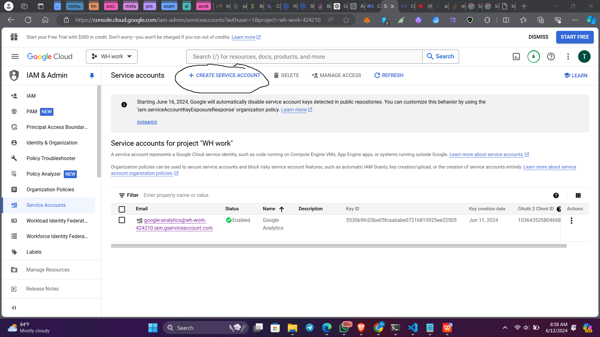

And download the json key of service account

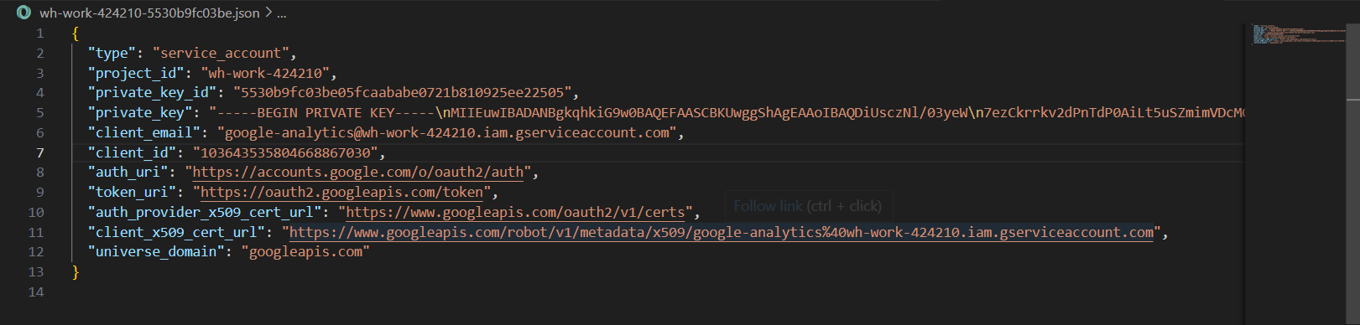

The key would look like the above image.

Step 2: Go to Analytics and add your app

In this step please remember to add google page tag in your application if not you will receive the below error T

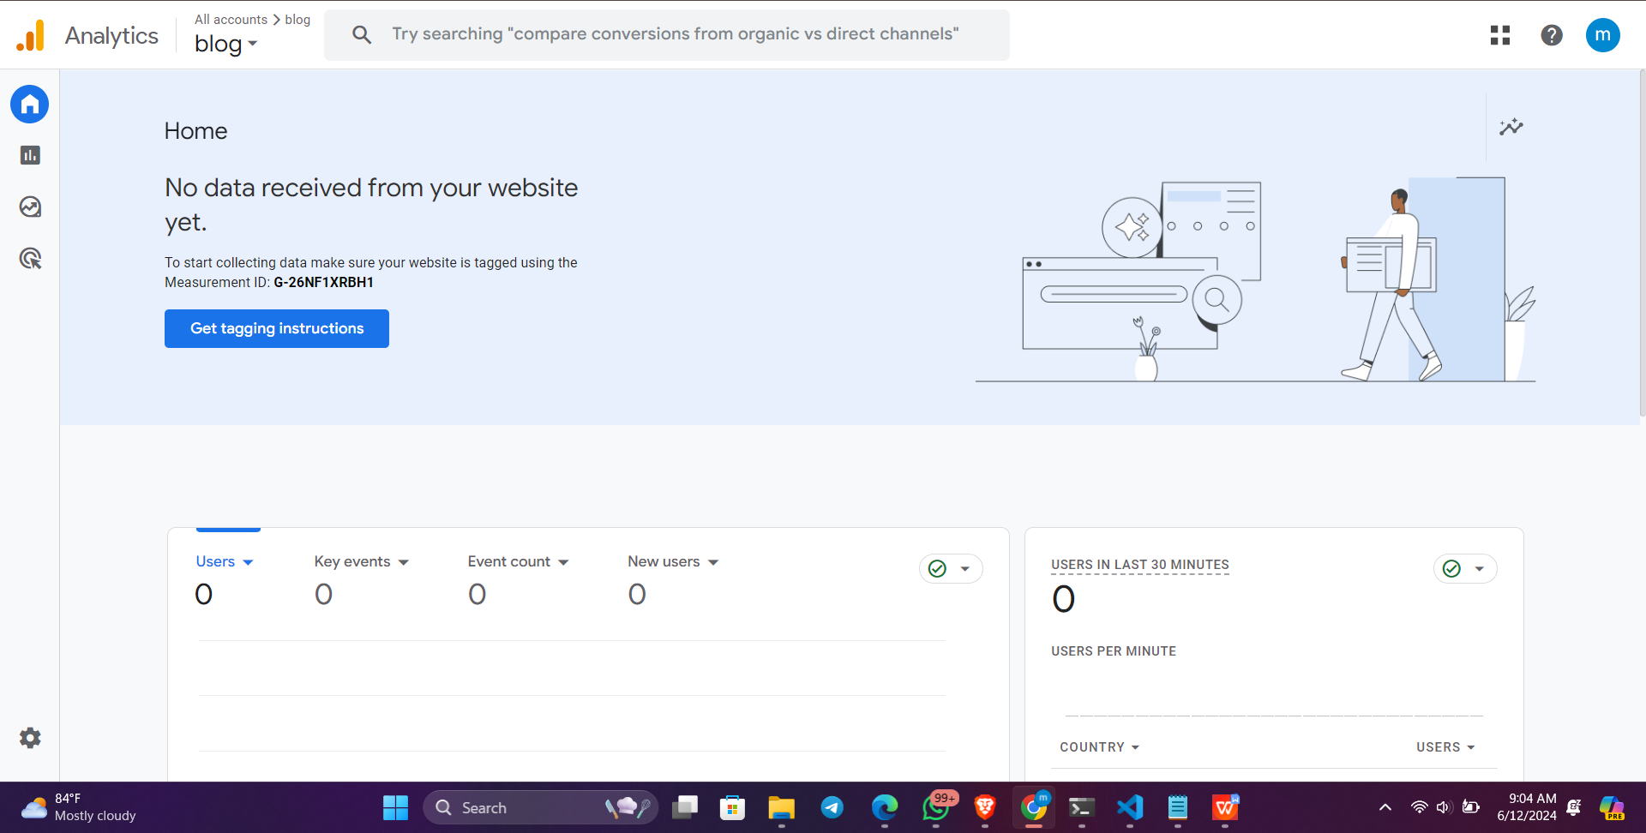

To add it you can choose the below methods

Either by manually or by using applications like wix,etc.

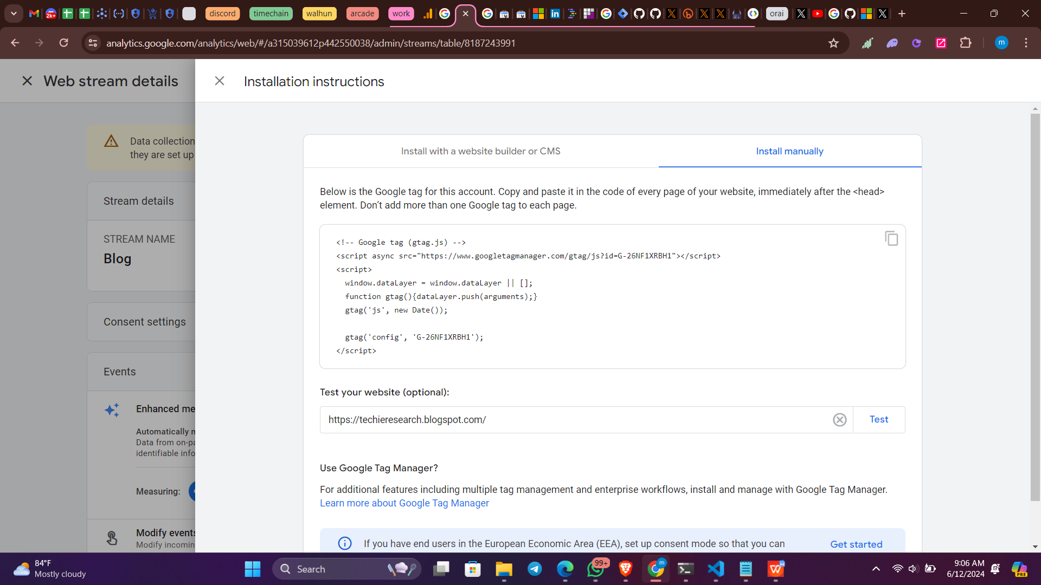

If going manually then do the below in your code.

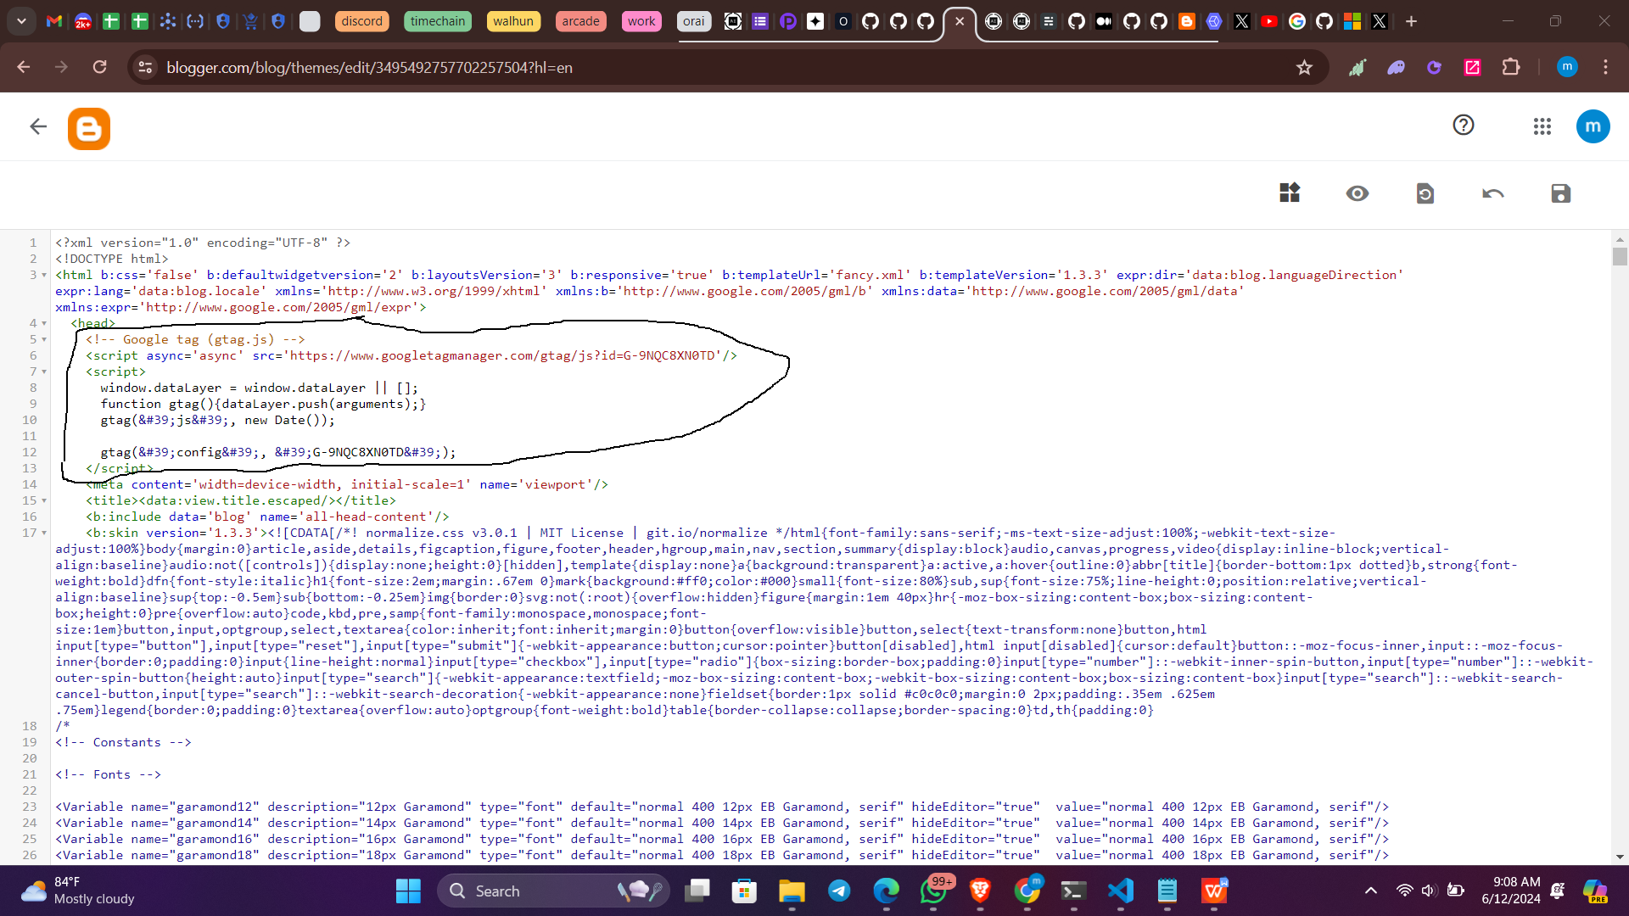

Once this step done you will be able to see the graphs updated

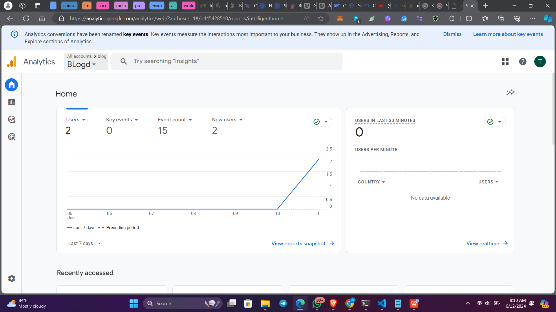

Step 3 : Adding gmail to analytics and retrieving property id

Now check the downloaded service key json, there you’ll find the gmail account

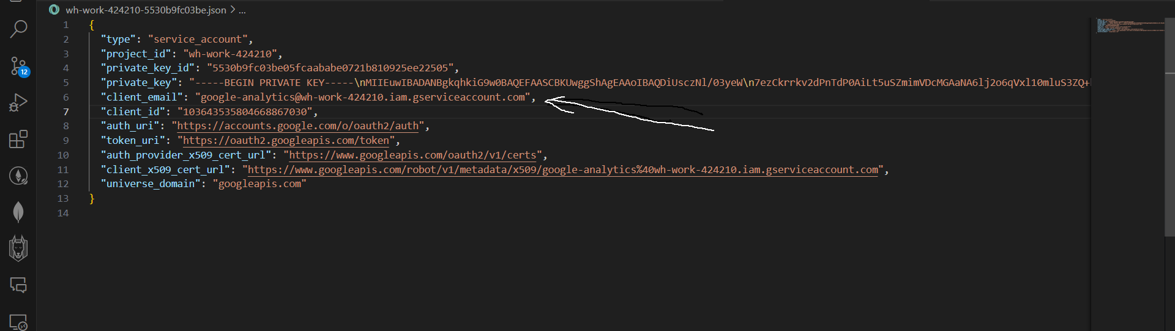

Copy the client email and now go to analyics in anallytics press Admin at the bottom left.



Now Go to Account Access Manager and then add user

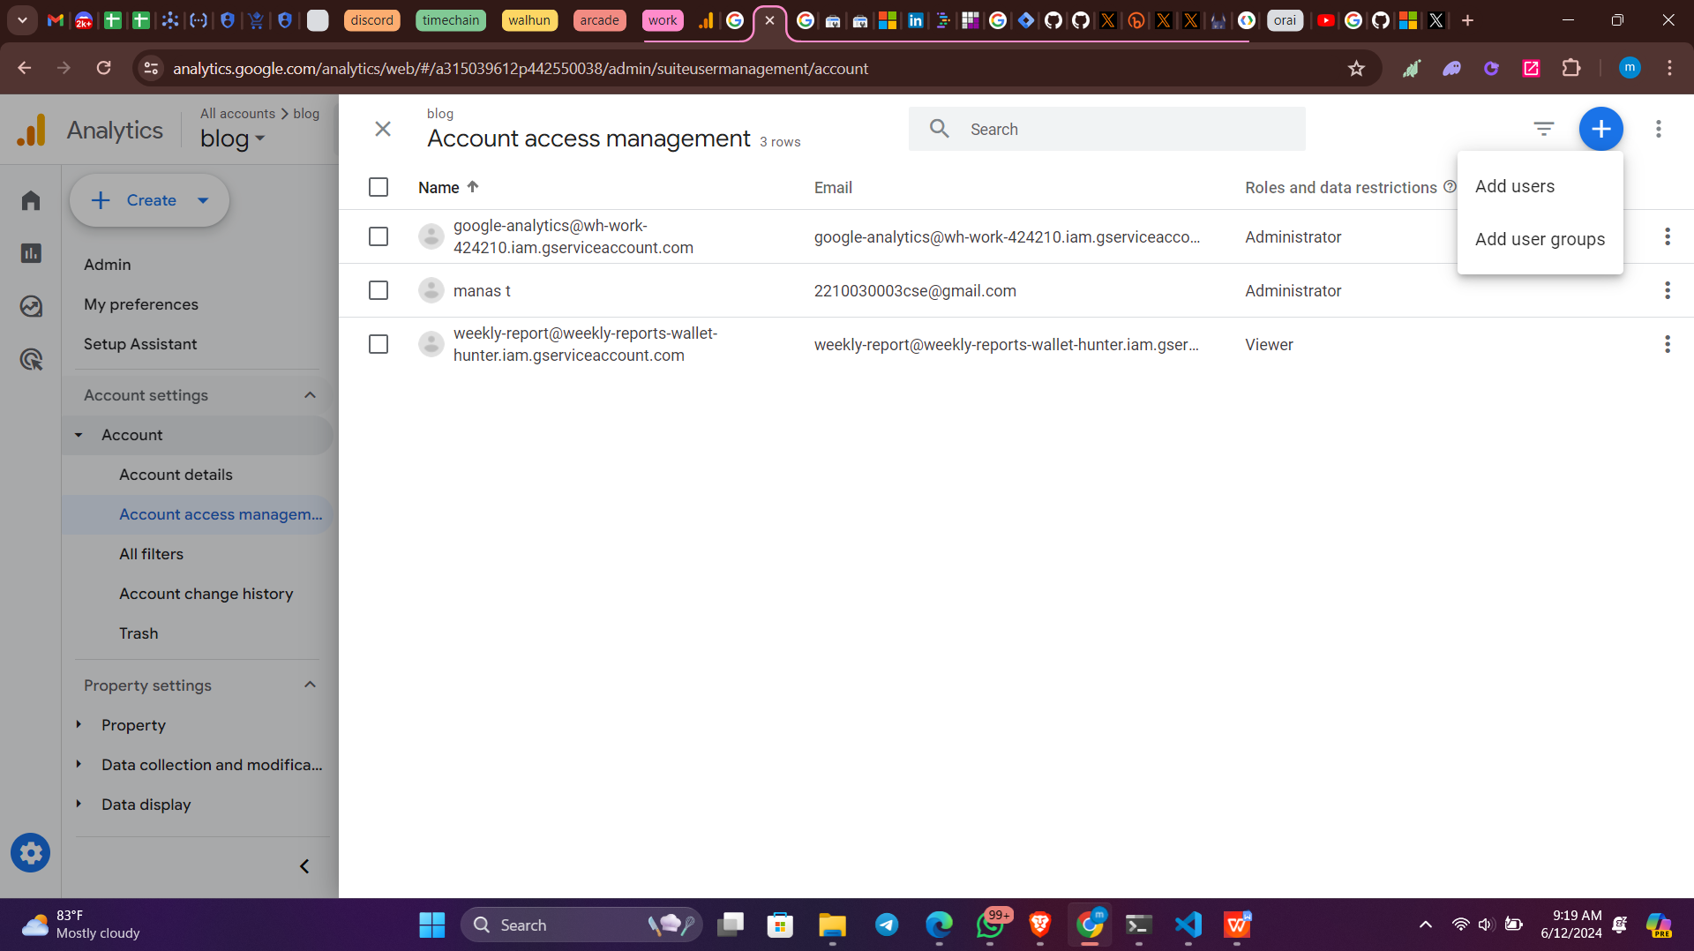

Give user a role such as viwer or administrator.

Preferable to choose Administrator.

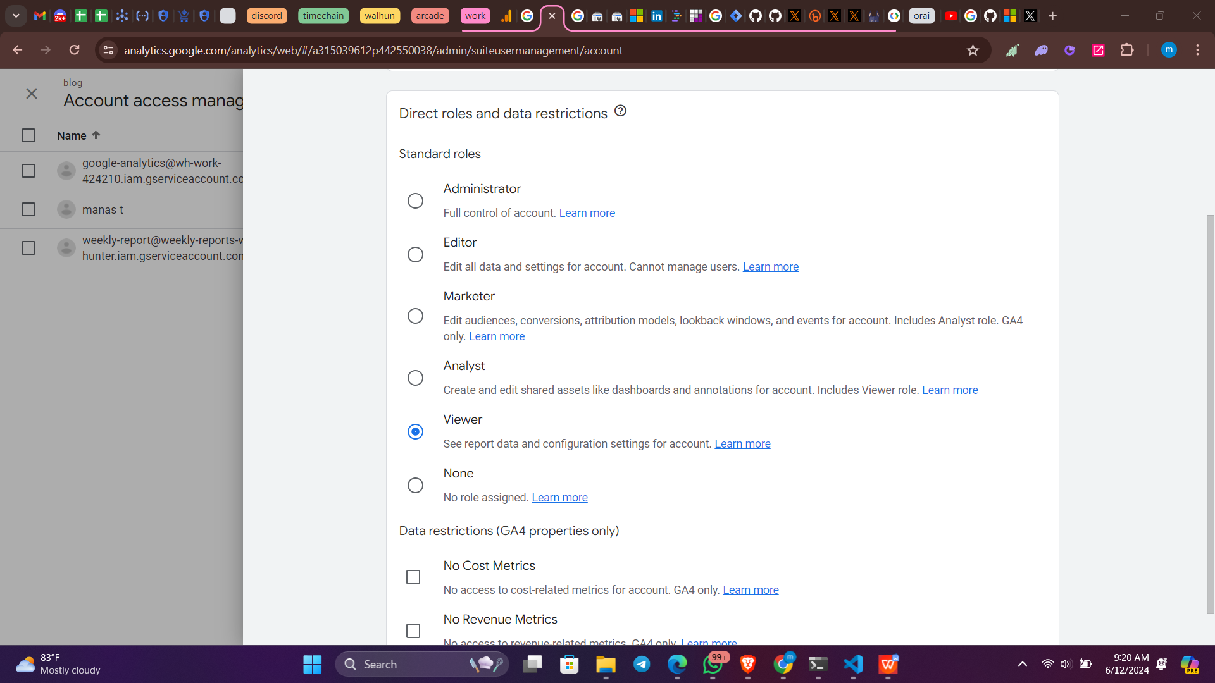

Now Go to Property and then Property details, copy the property id.

